PROG 2700 ASSIGNMENT 5 (PARTS A, B, & C) – SASS/SCSS, React

Part A: FreeCodeCamp
https://learn.freecodecamp.org/
Sign up with your Github account.
Complete the Tutorial Steps in the 'Bootstrap’,’ jQuery’ and ‘Sass' Portions under ‘Front End Libraries Certification'.

Part B: Code Academy & Tic-Tac-Toe Game Enhancements

PREREQUISITE (CodeAcademy):
Complete the following lessons in the Codeademy tutorial Learn ReactJS: (https://www.codecademy.com/learn/react-101):
- JSX:
  - Intro to JSX
  - Advanced JSX
- React Components:
  - Your First React Component
  - Components and Advanced JSX
- Components Interacting:
  - Components render Other Components
  - Props
- Hooks
  - The State Hook
  - The Effect Hook

INSTRUCTIONS

See the separate Assignment 5B document for detailed instructions on how to enhance the Tic-tac-toe application that we built while going through the tutorial together in class.

Part C: React-based Three-in-a-Row Game

Summary

- You will refactor the Three-in-a row game that we built for Assignment 4B into a React application.
- The React application will use the API data from both the original sample and random links.
- The React application will make use of React Routing to allow both the sample game grid and a random one to be chosen via links.

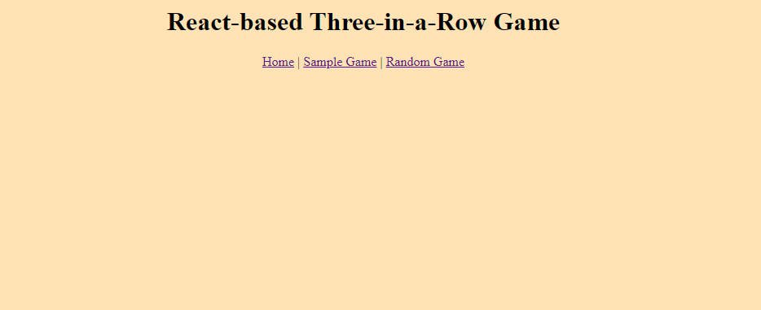
Home Page

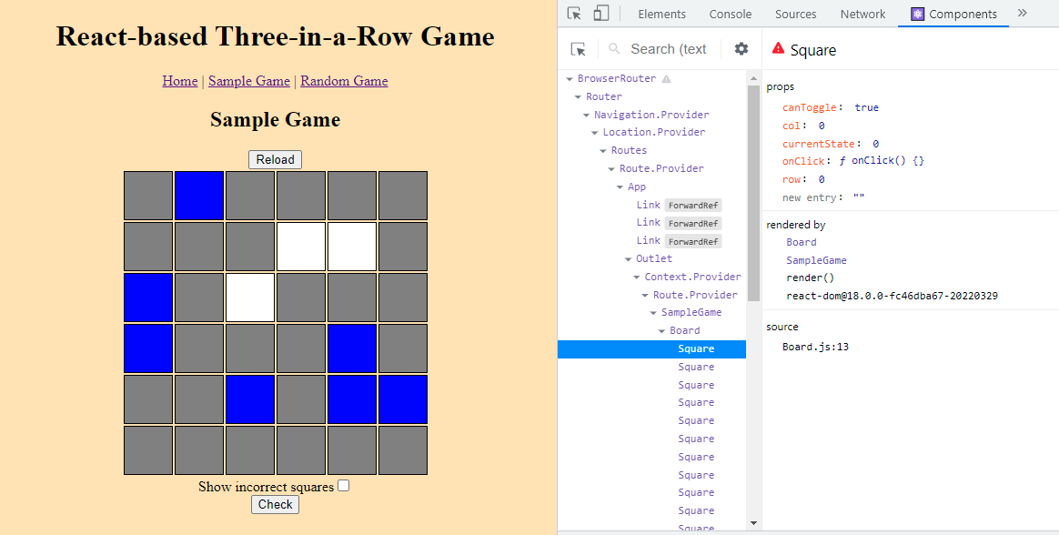
Sample 6x6 Grid

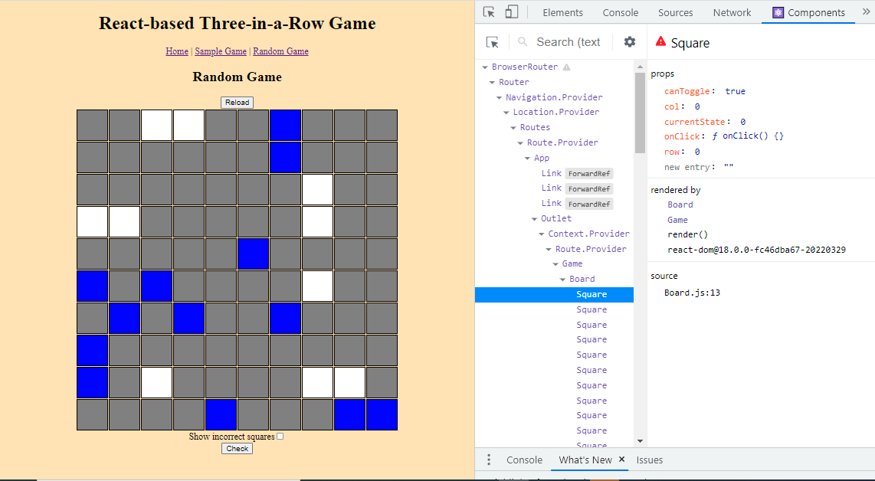
Random 10x10 Grid

- You will probably want to use the Tic-tac-toe game as a guide (i.e., my solution has a Square and Board component that is reused in both the Sample and Random games and that borrows a fair bit from the Tic-tac-toe game).
- The game should have all the same core functionality such as a Check button to check the grid for errors and a “Show incorrect squares” checkbox.
- Re-implementing your Innovative Feature from Assignment 4B is optional, though.

General Requirements (15 points)

- Retrieval of the JSON starting data for the Puzzle (3 pts.)
Your starting JSON data for the Sample Page puzzle will be retrieved from the URL https://threeinarow-api.onrender.com/threeinarow/sample. Your starting JSON data for the Random Page puzzle will be retrieved from the URL https://threeinarow-api.onrender.com/threeinarow/random. Either way, this data will be used to inform the puzzle of its starting state. It also will serve as the data for the puzzle as it is played. (i.e., your JSON object should be updated as events on the puzzle are performed.

- Drawing and Displaying of 3-in-a-Row Table with JavaScript only (3 pts.)
When the sample or random page loads, a grid based on the data structure defined in REQ-001 will have a similar display to the example images shown in Assignment 4B. Feel free to use alternative colors if you wish. Styling should be implemented with basic CSS.

You must use React with a mixture of CSS to build the above table. You are not permitted to use HTML tags to create the table and you are not permitted to use document.write to output the table tags.

- Changing of Square Colors with Mouse Clicks (3 pts.)
When the user left clicks on a square in the grid, the color (or image) of the square should change to the next available color (in this case blue). If the square is left-clicked again, the color will change to the next option (in this case white). Another click will remove the square back to a neutral color (in this case grey).
Squares that are assigned a color when the puzzle loads should not be changeable with mouse clicks.

- 3-in-a-Row Puzzle Status Checking (3 pts.)

A button is provided which when clicked checks the current status of the puzzle as described above in the bulleted list. When the user clicks the button, there should be an appropriate message displayed to them which accurately describes the current status of the puzzle. If the puzzle is complete and the squares are correct, clicking the button will inform them that the puzzle is correct and complete.

- Error Display Checkbox (3pts.)

A checkbox will be provided which when checked will mark any squares that have been incorrectly assigned. Unchecking the box will hide any error display.

Architecture Requirements (25 points)

- React Components used to Store the Entire Game State. (10 pts.)
The entire game state will be stored in an appropriate React Component.

- React Components used to Render each Square in the Board. (10 pts.)
Each cell/square of the table/grid will be rendered using an appropriate React Component.

- React Routing. (5 pts.)
React Routing and links will be used to load either the sample or random grid.

Instructions
- Don’t forget that a Code Review demonstration of your code is a necessary part of this assignment. You MUST complete the code explanation/code review part of the video submission checklist to get credit for the assignment. Part of the assessment will include your ability to speak about the code you wrote, even if it doesn’t completely work or do what you expect. You do not need audio or to speak during the rest of the video, but it is required for the code review section as indicated in the checklist.
- Late submissions will be subject to the late penalties laid out in the course outline.

Academic Integrity and Plagiarism
Code sharing by any means is considered plagiarism and is strictly forbidden under the NSCC Academic Integrity policy.
NSCC ACADEMIC INTEGRITY POLICY

PROG2700: Assignment Five - Video Submission Checklist
Part A:  FreeCodeCamp | Show the following, if not already given credit for Part A:  ☐ in the Browser log into FreeCodeCamp and show task completion
Part B:  Code Academy  & Tic-Tac-Toe Game Enhancements | Show the following:  ☐ in the Browser log into Code Academy and show task completion  ☐ Tic-tac-toe game runs in browser with Time Travel feature  ☐ Tic-tac-toe game runs in browser with Enhancement #1 feature  ☐ Tic-tac-toe game runs in browser with Enhancement #2 feature  ☐ Tic-tac-toe game runs in browser with Enhancement #3 feature  ☐ Tic-tac-toe game runs in browser with Enhancement #4 feature  ☐ show that the code uses appropriate React components
Part C:  React-based Three-in-a-Row Game | Show the following:  ☐ the program running and can chose the original 6 x 6 sample grid  ☐ the program running and can chose a random sized grid (refresh the page until you get something other than 6 x 6)  ☐ clicking on an “original” cell in the table does nothing  ☐ clicking on an empty cell in the table cycles between 3 states  ☐ activating the “Check Puzzle” button with an error  ☐ showing the error location with the checkbox checked  ☐ activating the “Check Puzzle” button with no errors  ☐ activating the “Check Puzzle” button with the grid complete (refer to the solution.png from Assignment 4B if you need help solving the grid)  ☐ in code, show the React Components used and storing game state  ☐ in code, show the React Routing setup
Code Review:  Mandatory | Show the following:  ☐ explain the React components used in detail for the entire application for 5C (needs audio)

